

**Retailer Newsletter**

**June 1, 2021**

**Tom’s Business “TIPS”**

***“To Improve Profits”***

**RE: Recruiting During These Tough Times (And Yes, They Are Tough!)**

**Hello,**

**If you have been a subscriber to my monthly ‘Tips’ for any period of time, you will remember two topics I write about the most are “Great Customer Service” and “Recruiting, Hiring, & Training”. I believe these two items are under the control of the owner and/or a top concern on their minds daily.**

**I have read countless stories and saw lots of news coverage how the new administration’s generous unemployment benefits are affecting small business. When I owned my stores, my experience with hiring and keeping qualified employees was always challenging. However, today~~,~~ it must be the stuff that keeps you awake at night thinking about how to fix it.**

**I suggest you review past issues on our website at ‘Tom’s Tips.’ The ‘Recruiting’ title will indicate which ones may be of interest to you.**

**[www.tsmanagementservices.com](http://www.tsmanagementservices.com)**

**Here are a few articles that I believe are worth reading or re-reading. Maybe some of these ideas did not appeal to you when you originally read them, but times are different with today’s climate. Maybe they are more relevant to your needs today. Be sure to keep an open mind as you review the list:**

* ***You Can Be Respectful* (Apr 2021)**
* **Would you want to work for you? If you treat your staff harshly, with no respect, why would anyone work for you?**
* ***Virtual Recruiting & Hiring* (Feb 2021)**
* **Video Interview Software**
* **Applicant Tracking System to help manage and automate recruitment.**
* **Job Application on Your Website**
* ***Training Does Cost, But it Does Pay $$* (Nov 2020)**
* **If you currently do not offer any formal training for your staff, you can begin by starting out small. Some training is better than none! Increase the amount of training you provide to all CSR’s over time.**
* ***Keeping Your Recently Hired Staff* (Sept 2020)**
* **Why it’s better to hire slower.**
* ***Starting Salary* (Aug 2020)**
* **12 vital tips for interviewing.**
* ***Employee Appreciation Day* (Sept 2019)**
* **I observed Costco treating staff to a free BBQ.**
* **Ideas I used to show my appreciation to my employees during hot summer months.**
* ***Retention & Recruiting* (Jul 2019)**
* **#1 reason most employees quit is because they feel uncomfortable doing their job, which means they were not properly trained when hired. They don’t feel right making decisions or answering customer complaints/issues. Start out with a training program from Day 1.**
* ***Job Fair* (Oct 2018)**
* **A different approach others try to recruit CSR’s.**
* ***More Recruiting Tips* (Aug 2018)**
* **Utilize our 5-day Training Checklist.**
* ***Recruiting Tips* (Jul 2018)**
* **Is your starting wage competitive with area businesses?**
* **Prepare a Recruiting Handbook for use during interviews.**
* ***C-Store Recruiting* (Mar 2018)**
* **Treat your staff with R E S P E C T.**
* **Let your staff know you are looking to hired qualified people.**
* **Be sure you are accepting applications whenever open.**
* **Hand out $10 gift card to qualified applicants.**
* **Use Recruiting Cards**
* **Consider flexible working hours.**

**In an effort to improve ‘Recruiting, Hiring, & Training” at your store, I’m recommending that starting today you implement…**

* **Recruiting Card - this is a business card size advertising item about your business. You and your manager(s) should always carry a couple and be on the lookout to hand one to somebody you meet that is providing Outstanding Service. I tried to set a goal to hand out at least one card a day (on average) when I owned my stores. We all agree newspaper ads are fruitless (and expensive) given the few people reading newspapers today. Here’s an example of the recruitment card.**

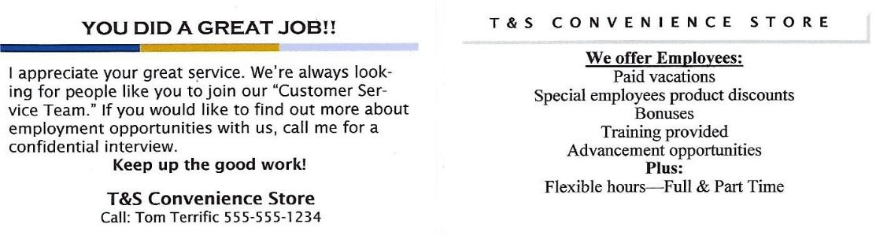

* **Quick App – this handy Application for Employment should be available for your CSR’s to hand out whenever you are open.**
* **Interview Manual – this will help your interview process and ensure you are asking the right questions to all prospective applicants.**
* **Add a job application to your website. See Feb 2021 *Tom’s Tips* for suggestions.**
* **Download our 5-Day Training Checklist. Start out using a sheet or two, and gradually increase as you feel comfortable.**

**I’ve heard numerous stories about possible fuel shortages this summer. If your supplier allows, you might consider ordering fuel before your tanks run too low. In other words, you should consider operating on the top half of your fuel tanks. Just a thought!**

**If your state, county, or city is still mandating wearing a mask, please, please be sure your staff is wearing one! *I strongly suggest you encourage your staff to get immunized to protect others they may come in contact with.***

**I hope you, your staff, and family stay safe and well during these trying times. I can see the light at the end of this long dark tunnel and it’s getting brighter, finally! 😊**

**Don't be a victim of the 5 Dangerous Words –**

***‘Maybe I’ll Do It Tomorrow’***

**Do it today because tomorrow (~~could be~~) will be too late!**

Tom                                                                       
Thomas W. Terrono

**T&S Management Services, LLC  
Instructor / Consultant for the Convenience Store Industry  
Lee's Summit MO 64082-4864**

**816.550.8048**



**[tom.tsms@gmail.com](mailto:tom.tsms@gmail.com)**

**[www.tsmanagementservices.com](http://www.tsmanagementservices.com)**

***“Our business is making your business better!”***