
Retailer Newsletter
June 1, 2026

Tom’s Business “TIPS”
“To Improve Profits”

RE: Another Look At Customer Service

Hello,

I recently hosted a town hall that included a presentation on Cash Control/Shrink. During the event, I spoke with a retailer I first met several years ago. When she introduced herself, she said, “Don’t be a victim of the five dangerous words—do it today.” I smiled and replied that she must be a loyal reader of Tom’s Tips. She laughed and shared that she saves every issue in a file on her computer and revisits them from time to time to refresh ideas and gain new perspective. She also noted that I frequently emphasize customer service. I agreed and explained that while we cannot always control prices, we can always control how we welcome and serve customers when they walk through the front door. She added that the way she treats her staff is directly reflected in how they treat customers. I told her that many of my customer service stories come from my own experiences shopping in convenience stores, other retail businesses, and restaurants. More often than not, customer service is the deciding factor in whether we return to the business. Personal connections are valuable in convenience retail. Encourage employees to:
- Learn regular customers’ names
- Remember frequent purchases
  - I remember when I owned my stores and a regular customer walked in and their usual cigarette purchase is sitting on the counter. That always brought a smile to their face.

Unlike larger retailers, convenience stores depend heavily on regular customers who make quick, frequent visits. Good service can determine whether customers return daily or choose another store nearby. We may not always remember the price, but we certainly remember how we were treated. I also shared that in my humble opinion, the true measure of customer service is not only in the everyday greeting, but in how a customer’s problem is handled. A complaint may involve a product you sell, the service the customer received—or did not receive—or even an issue beyond your control. How you respond and resolve that concern is the clearest reflection of the level of customer service your business provides.

If you have attended a class with me in the past and the topic was Recruiting, Hiring, and Training, you will remember this slide:

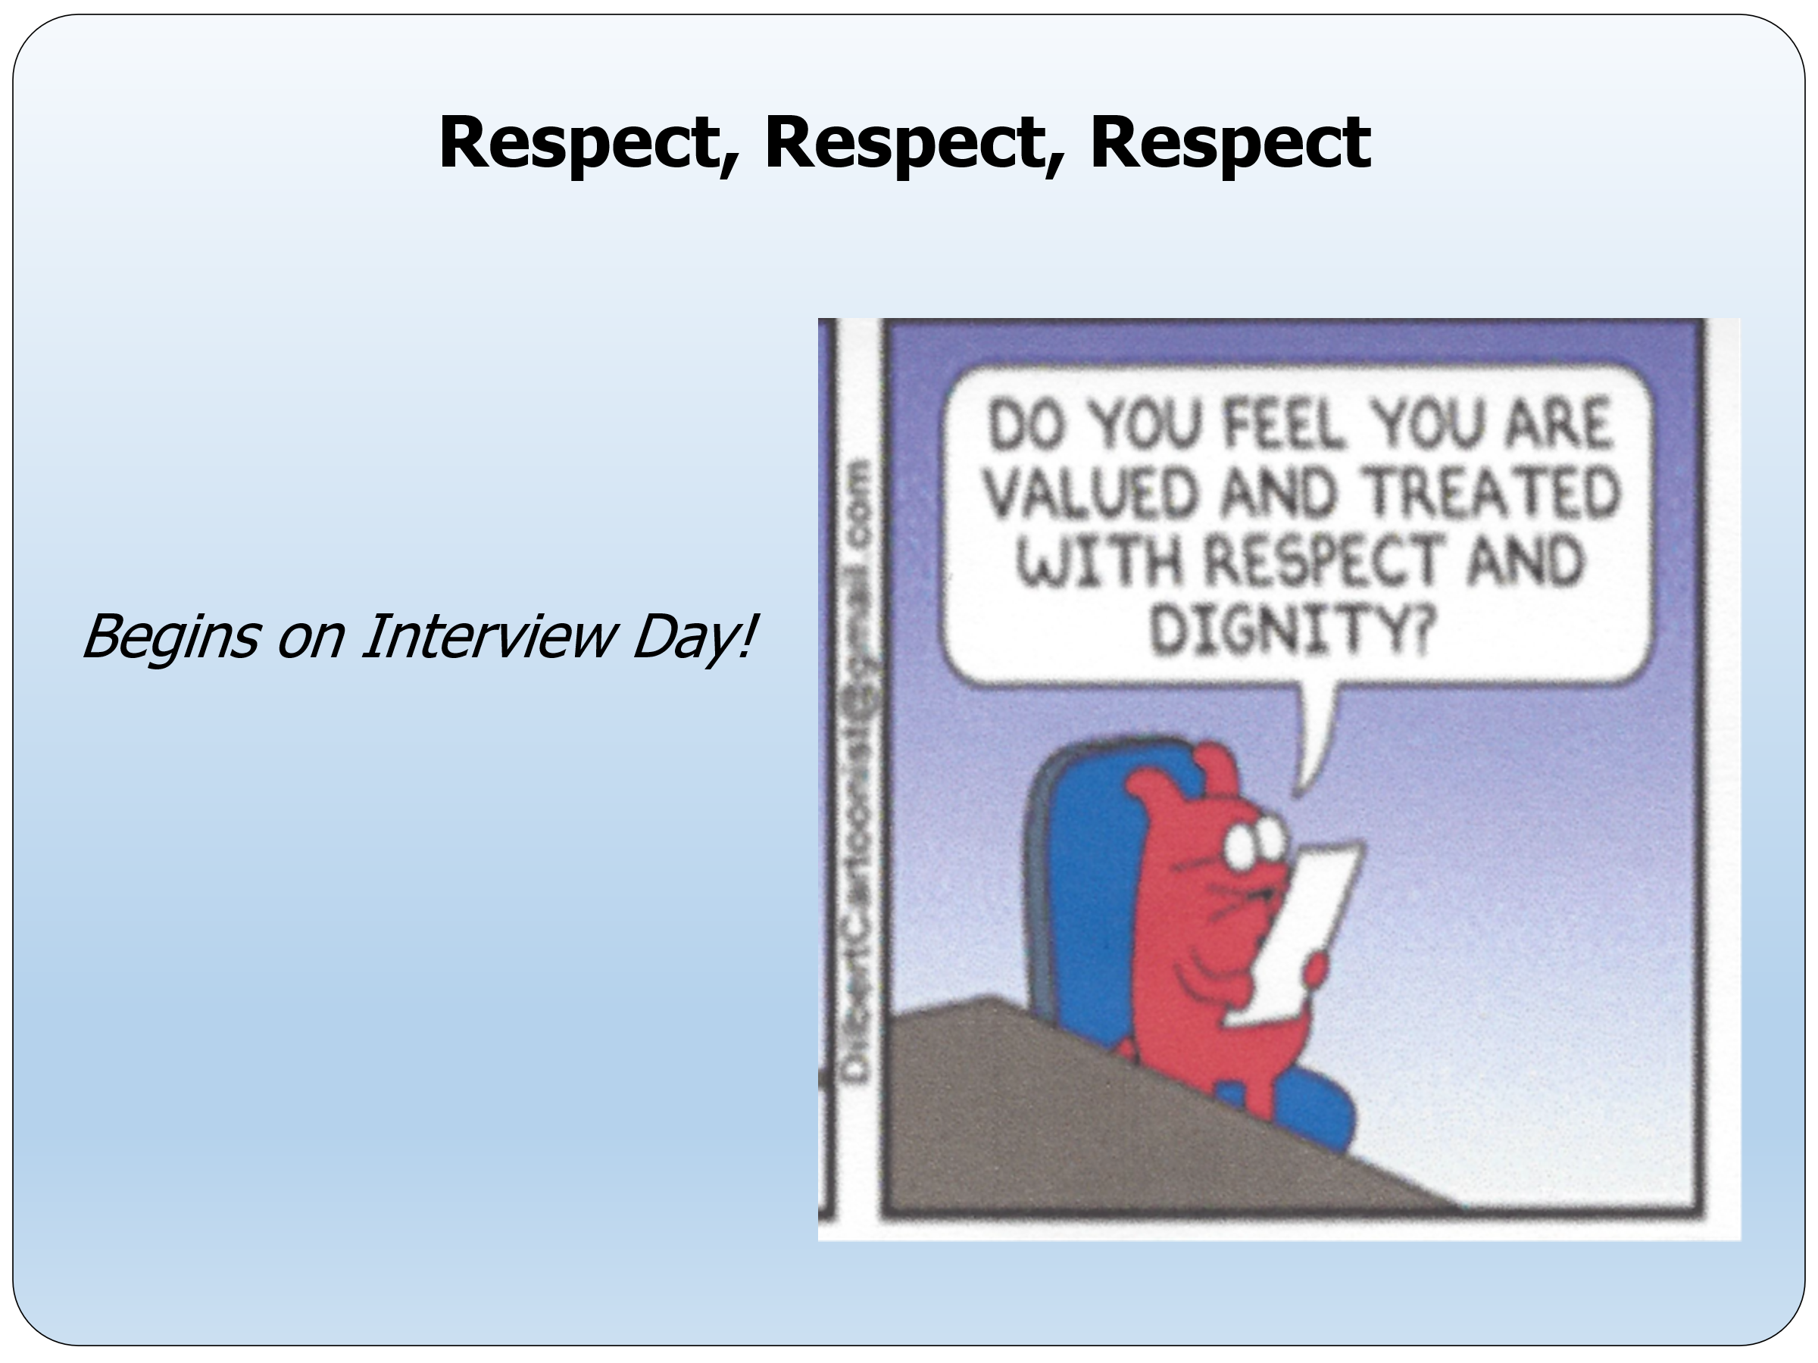

A recent article created waves throughout the airline industry. “Southwest airline CEO says a candidate for a senior position wasn’t hired because they were rude to the receptionist.” The article goes on to say that “taking care of employees helps ensure that culture filters down to passengers on the plane. We spend a lot of time making sure that we go overboard in treating our employees like family.” I have seen numerous c-store owners treat their staff harshly. I believe those retailers never realize that that ‘treatment’ filters down to the way their staff treats customers. That business culture is doomed for failure.

Fuel prices remain highly volatile and are likely to continue fluctuating in the near term. When I owned my stores, the industry experienced a range of challenges, from gasoline shortages and long lines at the pump to government-imposed price controls. Media outlets are always looking for a story, and whenever reporters called or visited my stores, my policy was that I was the only person authorized to respond to questions. At times, staff members may unintentionally share personal views or incomplete information that does not accurately reflect your position. For that reason, I recommend establishing a clear policy that no CSR or manager is permitted to speak with the media. All inquiries should be directed to you. This approach can help protect both you and your business from unnecessary confusion or embarrassment within your community. On the subject of gasoline, I have added a document to our website under “Forms and Reports for Your Business” titled Gasoline Octane Facts. It is a short, easy-to-read resource designed to help your staff explain gasoline octane when customers have questions. Remember, many retail clerks leave their jobs because they are not fully trained or do not feel confident performing their responsibilities.

Another thought on fuel prices is that we are due for a price drop, maybe a significant drop. There may even be times when the street drops right after you paid for a recent delivery. Always remember that your customers are watching street prices, even your competition. You must remain competitive. Hopefully, you made a little extra gross profit dollars when the price went up. Be fair to your customers (and yourself) when the prices decline.

If your store is not as profitable as you believe it should be, there is usually a reason. The good news is that most profitability challenges can be identified and corrected. A recent article on CSP Daily News stated that: “merchandise sales in 2025 had a 1.7% increase over 2024. That is the 23rd straight year of inside sales growth”. Food service accounts for 28.5% of total sales. If your store is not going in the right direction, make a change, do something different, and visit your competition to see what they are doing. Sometimes, small adjustments in merchandising, customer service, cleanliness, product mix, or food offerings can make a significant difference in profitability.

If you are a retailer looking for stronger store performance, higher sales, better customer service, and improved profitability, contact us.
If you are a supplier or organization working with retailers that are struggling to maintain profitable operations, we can help. Our experience in retail operations and customer service can identify opportunities to improve performance and strengthen results.

It costs nothing to have a conversation. A phone call, text, or email could be the first step toward improving your store’s performance and profitability.

* * * * * *
"If you don't have time to do it right,
when will you have time to do it over?"
John Wooden

* * * * * *

Don't be a victim of the 5 Dangerous Words
‘Maybe I’ll Do It Tomorrow’
Do it today because tomorrow (could be) will be too late!

Tom
Thomas W. Terrono
T&S Management Services, LLC
C-Store Rescue
Instructor / Consultant for the Convenience Store Industry
Lee's Summit MO 64082-4864
816.550.8048


tom.tsms@gmail.com
www.tsmanagementservices.com

“Our business is making your business better!”

