**Electronics**

For electronics, such as tablets, touch screens, keyboards, remote controls, and ATM machines

* Consider putting a wipeable cover on electronics.
* Follow manufacturer’s instruction for cleaning and disinfecting.
* If no guidance, use alcohol-based wipes or sprays containing at least 70% alcohol. Dry surface thoroughly.
* At my stores, we always kept the POS and computer keyboards were covered with heavy-duty plastic wrap. This also prevented damage from spills. If your POS is touchscreen, follow manufacturer’s instructions for cleaning.

|  |  |
| --- | --- |
|  | **Do** |

|  |
| --- |
| * Wash your hands prior to sanitizing electronics. * Wipe the entire surface of the screen and keyboard, if equipped, with a bleach-free disinfectant wipe or a soft cloth dabbed in isopropyl alcohol. Look for “Bleach Free” in the ingredient section of the product label (e.g. Clorox or Lysol brand wipes). * If using a disinfectant spray, be sure to spray onto a soft cloth or towel before wiping screen. |

|  |  |
| --- | --- |
|  | **Don't** |

|  |
| --- |
| * Use excess force when cleaning computer screen/monitor. * Use bleach or abrasive cleaning products to disinfect computer screens. Bleach can cause damage, including discoloration and fading. * Spray cleaner directly onto electronics; this can cause liquid to drip into the computer and cause damage. |

**Enhanced Cleaning for Prevention (General Guidance)**

* Wash your hands often with soap and water for 20 seconds.
* Always wash immediately after removing gloves and after contact with customers.
* Hand sanitizer: If soap and water are not available and hands are not visibly dirty, an alcohol-based hand sanitizer that contains at least 60% alcohol may be used. However, if hands are visibly dirty, always wash hands with soap and water first.
* Additional key times to wash hands include:
* After blowing one’s nose, coughing, or sneezing.
* After using the restroom.
* Before eating or preparing food.
* After contact with animals or pets.
* Before and after providing routine care for another person.
* Increase the frequency of cleaning and disinfecting, focusing on high-touch surfaces, such as cooler doors, store entrances, cashier counter, ATM, and pumps.
* Pens your customer use or credit card stylus pens should be cleaned hourly, at a minimum.
* Keep a container of Hand Sanitizer available for customer & staff use.
* All staff members should be required to wear facial masks and gloves, at all times.
* Public Restrooms
* Doorknobs, handrails, faucets, flush valve handles, sinks, changing tables, and faucets.
* Be sure your soap dispensers are fully stocked.
* Utilize paper towels and/or blow dryers.
* Touchless operation is best

**Here are some widely used products.**

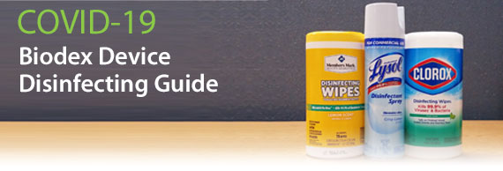

**Please Maintain**

**Social Distance**