Retailer Newsletter
April 1, 2023

Tom’s Business “TIPS”
“To Improve Profits”

RE: Would You Like To Work For You?

Happy Spring to one and all,

1. Ask yourself an important question:

Recently while having lunch with a group of friends at a local restaurant, a man I didn’t recognize walked up to me and said, “You’re Tom Terrono, right?” I cautiously answered, “Yes, I am”. The man then told me his name and said he had worked for me many years ago. To be honest, I did not remember him. He said he just wanted to tell me that he thought I was the best boss he had ever worked for. He went on to say that he worked for me when he was young, and at that time, he did not appreciate what I was doing as his supervisor. Because his comment caught me off guard, I was at a loss for words. My friends sitting around the table just smiled because they couldn’t believe what they had just heard. As he left, I thanked my former employee for his kind words. I have had hundreds of people work for me over the years, and I will be the first to admit early in my career I didn’t know what it took to be a good supervisor or a good boss. I have always remembered something I was taught by a former supervisor when I was managing one of the service stations on the Kansas Turnpike. He asked me, “Would you like to work for you?” That quote stuck with me since that day, over 50 years ago. If you treat employees with respect, even when tough discipline is warranted, or when business conditions were rough, they will usually respond with respect in turn. Now I would be less than honest if I told you that I fulfilled that commitment each and every day because I didn’t, but I did try. I suggest you write that quote down, “Would you like to work for you?” and put it in your car, on your desk, or somewhere you will see it every day. Try it!

2. Digital Marketing:

“78.9% of shoppers surveyed used a mobile device to search for a c-store.”
Source: NACS Magazine
- Websites

That quote brought back memories of a recent training session, regarding “Digital Marketing”. During this class, we discussed various ways of marketing your store. One valuable idea is the use of a store website. Here are just a few companies that can help you get started:
- wix
- web.com
- network solutions
- hubspot
- bluehost
- squarespace
- gosite
- domain.com

We use Wix for the T&S Management website. We have found it to be extremely easy to use. I never had to call on my granddaughters once for help . It allows you to copy and paste, which is not possible on some other sites. We pay an annual fee of less than $200, plus a fee to maintain your Domain Name. For an extra fee, Wix can assist you in developing and improving your website. We did not need this service (and I’m not a supercomputer guy). We also receive daily reports stating how many ‘hits’ our website receives, from what part of the country they come from, or what other location in the world they have been read.

- Email

Here are some sites that will assist you when using Email to attract customers to your store:
- sendinblue
- hubspot
- constant contact

- Texting

Here are companies that help you get customers to your store using texting:
- text-em-all
- simpletexting
- twillo

Some of these companies do provide a Free Trial Period to see if it will work for you and your business. If you are unsure of your tech skills, or if you don’t have enough hours in your day, ask a trusted employee if he/she would have some interest in setting these up for your business. I do suggest you keep control of the various methods of communication by holding onto passwords to access and change.

- Lack of Training/Liability

I recently learned that a local convenience store is facing a lawsuit because an on-duty CSR allowed a customer to put gasoline in a glass bottle. This mistake resulted in a tragic fire and a lawsuit followed. The CSR claimed she didn’t know it was illegal to allow customers to put gasoline in a bottle. My question for you is; have all your employees been trained on what is a proper container for fuel? Do you have documentation that the training has been conducted? For many of you, the answer is a Yes and a No. ‘Yes’, you told them, but ‘No’, you do not have proof of it. I have a solution for those of you that do not have proof. On our website under ‘Forms and Reports for your Business’, we have a 5-Day Training Checklist. Under the category ‘Safety’, we list ‘Approved Gasoline Containers’. In this part of your New Hire/Annual Review of your employee training program, you can validate that employees have been properly instructed what containers are approved. This employee training checklist could prevent a major incident that could lead to a major problem for you! Remember, it’s a proven fact, “40% of all businesses do not survive a disaster”. I’ve given you the tools that can help avoid this calamity, it’s up to you to take the next step and follow through!

- Store Damage Protection

I frequently read stories about cars crashing into the front of convenience stores. Apparently, this type of accident occurs many times each day across the country. Often this accident is the fault of the driver, but sometimes the store is held responsible due to the open area around the front door. The solution to this problem could be the installation of safety bollards. (See the following photos). A side benefit to consider is these posts can prevent unscrupulous individuals from ramming your front doors when you are closed and stealing items from your store, like your ATM. Be sure and add this to your Safety & Security planning at your stores.

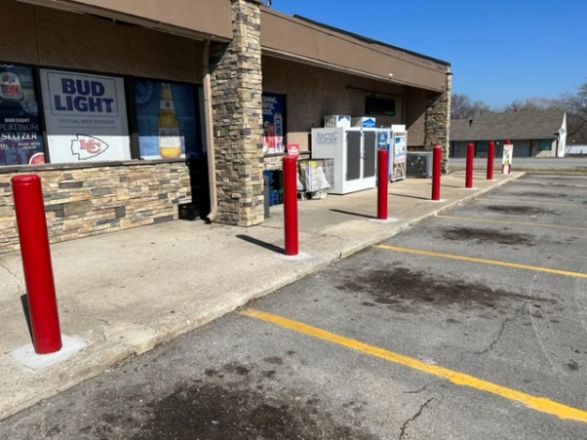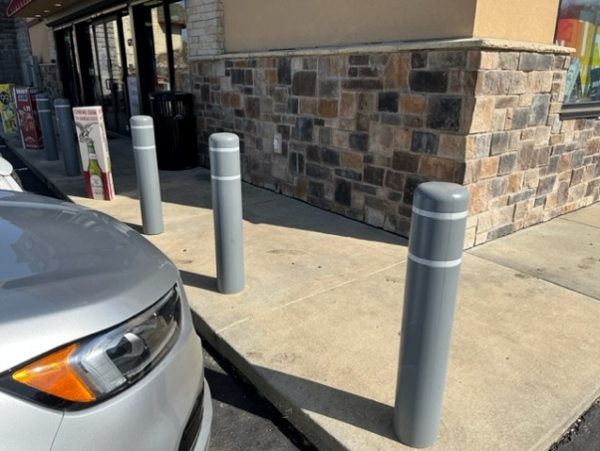

- Move that merchandise out:

Since we have now officially entered Springtime, it’s time to review your ‘winter items’ on display. If you still have ice melt, scrapers, and snow brushes on hand, it’s time to offer them at a deep discount and move them out. If you don’t move them out and free up shelf space (or front counter space), you will give your store the ‘cluttered look’ and customers cannot find the item they are interested in due to the disorder. These items get dust-covered and unsightly during the off-season months, which is why I have always thought it was better to start the next winter season with clean, new items to sell.

- T & S Service and Products:

Continuing with my commitment to share some items we feature on our website each month:

- In-Store Consulting – This section describes what we can do to help your business. The ‘At-Store Visit’ offers a service that cannot be done in any classroom (training) session. Just “click” Learn More for more information.

- Forms & Reports For Your Business:
  - Business Self Analysis Form – Meeting the Competition. This worksheet is used in conjunction with our presentation ‘Meeting the Competition’. This class was requested by a marketer whose retailers were faced with numerous new sites (new competition) in their area. This class illustrates many photographs, some of which are good, and some not so good. Many of the attendees commented, “I never compared my store to my competition until I looked at the pictures my customers must be seeing when making the decision on where to shop.

  - CSR Job Description – this form should be shared with all new applicants in an effort to allow them to understand some of the duties they will be required to perform. On Day 1, when they are hired, this form should be signed and placed in the employee’s file. This document is written in WORD so you may make changes specific to your store’s needs.

"There is no limit to the amount of good you can
do if you don't care who gets the credit."
- Ronald Reagan

If your store is not as profitable as you think it should be, give me a call or email. If you are a supplier or organization with retailers, and they are struggling to maintain profitable stores, please reach out to me. We can help these stores’ operations and improve profitability!

Don't be a victim of the 5 Dangerous Words –
‘Maybe I’ll Do It Tomorrow’

Do it today because tomorrow (could be) will be too late!

Tom
Thomas W. Terrono
T&S Management Services, LLC
C-Store Rescue
Instructor / Consultant for the Convenience Store Industry
Lee's Summit MO 64082-4864
816.550.8048

tom.tsms@gmail.com
www.tsmanagementservices.com

“Our business is making your business better!”

